Chapter 3, Problem 45.

Find current i in the circuit in Fig. 3.91.

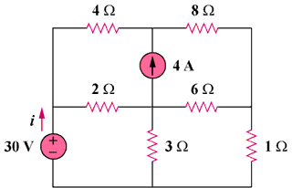

Figure 3.91
For Prob. 3.45.

